1-Page Quick Guide
See page 4 for detailed manual
- Login at: nccnewsonline.net using SU user ID and password. At left, hover over POSTS and click ADD NEW.
2. Headline  must have a subject and a verb. No secondary head needed.  3. Byline and Dateline all in bold  By Tim Frank FULTON, N.Y. (NCC News) —  4. Article text goes here. Use hyperlinks.  5. Click Category  i.e. business | 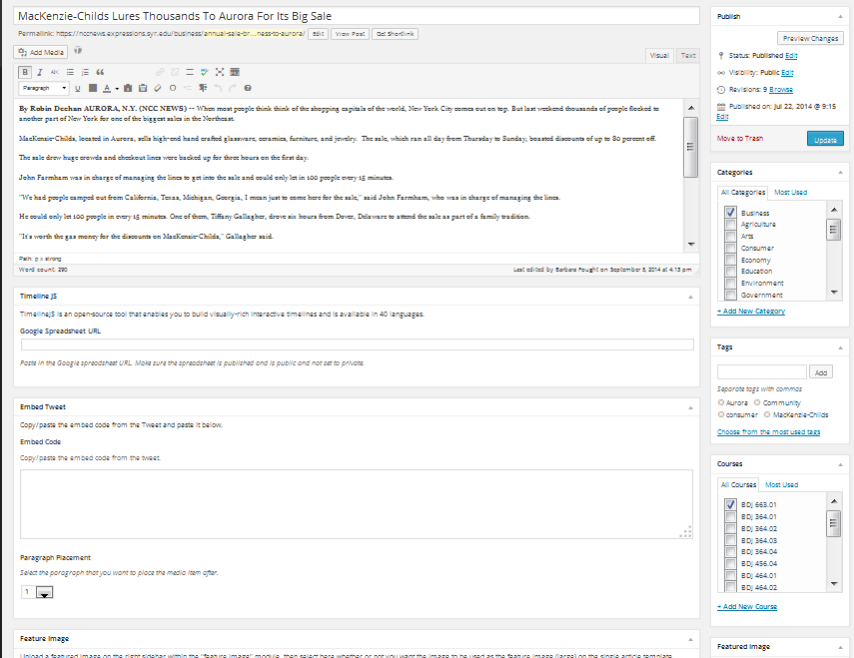 | 6. Choose from tags – narrower topic than category.  7. Click your course: SUPER important!!  8. Add featured image (photo). Write caption as a sentence of news, adding to what the photo shows. End with: (c ) 2018 Juanita Perez  Note: this shows up at the top for BDJ 364 posts; as the small thumbnail for stories with video
TO ADD VIDEO
Enter the link from YouTube, copying only text after the “=” sign or between the “=” signs in the YouTube URL. | 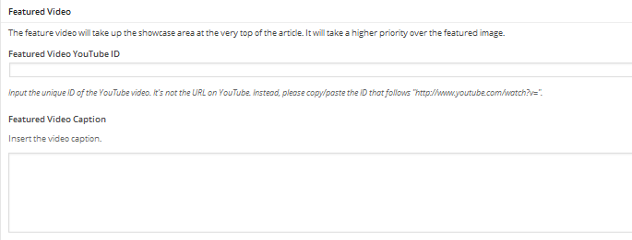 | Write a complete sentence of news summarizing the video story. End the sentence with: (c) 2018 your name
TO ADD additional photos and audio use the Fields Table
Add photo to appear within the text. Add caption.  The caption should be a sentence of news adding to what the picture shows. End with  © 2018 Tasha Jones  Save. |  | Audio: Save story first as a draft. Write headline in “Post Title”. Write a summary of story in “Caption,” such as: Hear mayor talk about new stadium. See pg 7 for how to upload from SoundCloud .
Checklist: Avoid the 10 Most Common Mistakes

- Spelling is correct.
  - See what’s underlined in red or click
- Headlines have a subject and a verb.
  - The headline is no more than two lines.
    - Words in the second line extend at least halfway across.
  - Each word in the title headline is capitalized.
  - Subheads are not required, but can be used for a long story.
- The byline/dateline is formatted and capitalized correctly, in bold.
By Firstname Lastname CITY, N.Y. (NCC News) --- The story starts here…
Examples:
By Mannie Holmes CAZENOVIA, N.Y. (NCC News) – The Town of Cazenovia is …
By Nigel Duara TROUTDALE, Ore. (AP) --- A teen armed with a rifle ….
Note the capitalization: Only the city is all caps. State abbreviations are AP abbreviations, not postal abbreviations. Use a dash at the end, not a hyphen.

- Verbs are past tense.

- Quotes are punctuated correctly, with attribution after the first sentence.

Examples:
“It’s great that the state has done this,” Strobel-Gower said. “People with disabilities don’t use the word handicapped, and haven’t for a long time.”

“I feel sorry for the taxpayers, but this is a much bigger problem than just the Town of DeWitt,” said Jim Clune, one of the protestors. (Put “said” first if a phrase comes after the
name.)
- Photos are horizontal, not vertical.

- Photo captions are a sentence of news with a subject and a verb. They add news or information to what the picture itself communicates.

- The photo copyright notice follows this format: (c) 2018 Newie Newhouse

- The story is tagged by topic and by class, and any audio or video includes a transcript.
- You’ve looked at the published story online. Video and audio appear at the top and play correctly. Any additional photo(s) or tweets appear flush left with text wrapped around it.
SAMPLE STORIES
Here are examples of what stories should look like:

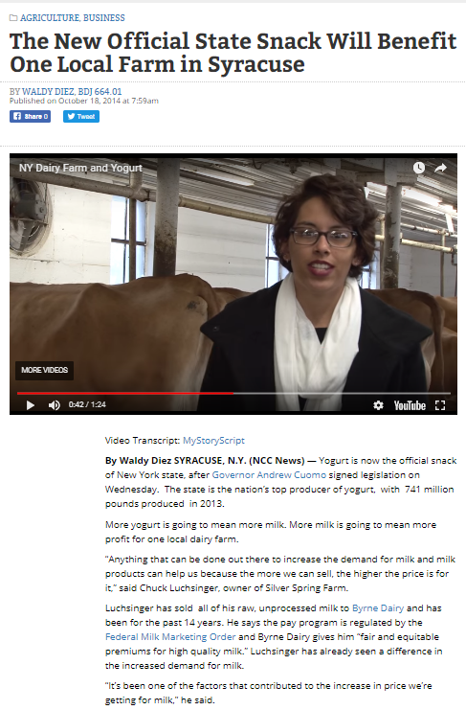
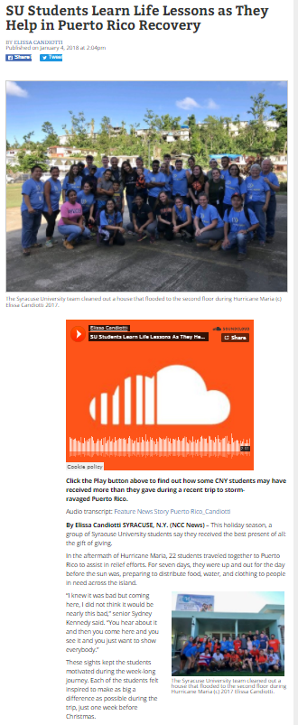

Detailed Manual
- Login at nccnewsonline.net with your  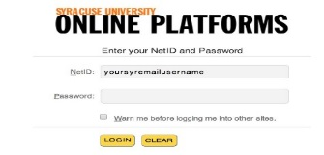  SU user ID and password | 2. Create a new article  Hover over the button. Click “Add New.”  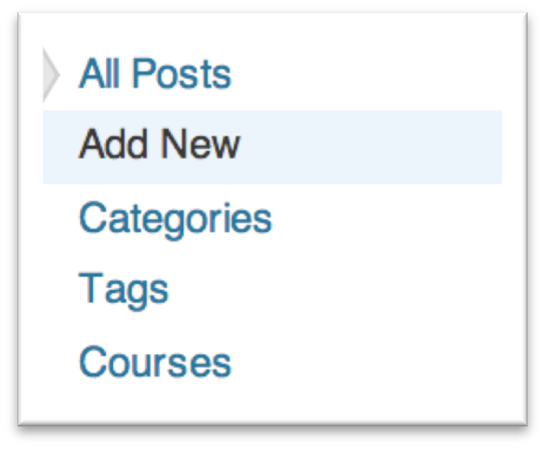

3. Write the headline
Enter a title (headline) in the empty box under “Edit Post.”
- Make sure it has a subject and a verb. It should be no longer than two lines and if it goes to a second line, the words should go at least halfway across.
- We no longer use secondary heads. Use sub-heads in the text only if you have a very long article.

4. Enter the article content
Start article with a bolded byline.  Format is: By Firstname Lastname SYRACUSE, N.Y. (NCC News) — start article here  Note: The city is the location where the story occurred. City names are all caps. | 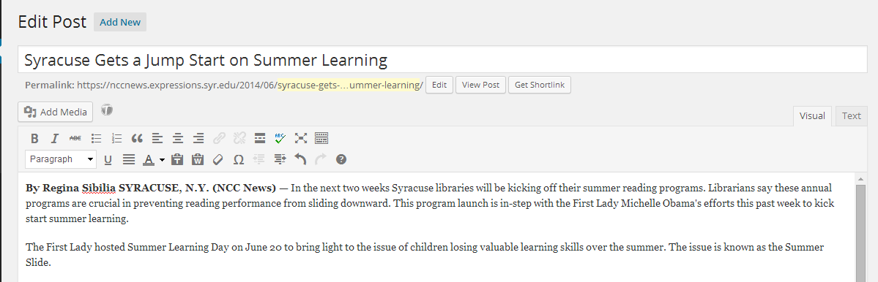
State abbreviations are in initial caps and are AP style abbreviations, not postal abbreviations. Put a dash at the end, rather than hyphen.
This opens up a second line on tool bar. See next page
5. Edit and format your article
Here’s an explanation of the tools, first line, from left to right:
Bold: Create bolded font.  Italics: Create italicized font.  Strikethrough: Create font with a line through it.  Unordered List: Create a list in your article with bullets.  Ordered List: Create a list with number.  Blockquote: Highlight/indent a quote.  Align Left: Align text to the left. | Align Center: Align text to the center.  Align Right: Align text to the right.  Link: Add a hyperlink to words in your article.  Unlink: Take a link away from words in your article.  Insert More Tag: Do not use. Does not work. Distraction Free Writing Mode: Allows for simpler format in writing screen.
The last icon on the first row-- the kitchen sink, gives you this second row:

Format Bar: The default is paragraph. Use it.  For subheads in a long story: use Heading 2  Underline: Font is underlined.  Align Full: Create fully-aligned text.  Select Text Color: Leave black  Paste as Plain Text: Use when you paste from the web or another document so text is formatted correctly.  Paste from Word: Use when you paste from a Word document | Remove Formatting: Removes all changes made to format from highlighted text.  Insert Custom Character: Gives a choice of many custom characters.  Outdent: Moves indented text back to the left.  Indent: Indents text to the right.  Undo  Redo  WordPress Help

6. Set Your Feature Image
This photo shows up at the top of the stories without video (364 posts). It’s the thumbnail photo in the story list for video stories.
a. Look in the right column and scroll down under “Courses” to find the “Featured Image” box. Click “Set Featured Image.”  A new box will pop up. Before loading your photo, make sure the screen is set to “Upload Files.” |  | 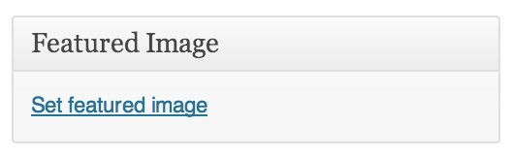
b. Click “Select Files” to find your feature image on your computer. | 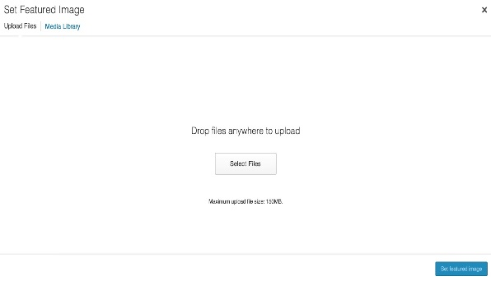

Note: Since the picture tells a story, write the caption to add additional information. Don’t just
describe the photo. Example: Edamame is being pulled off CNY grocery shelves because of listeria fears.

IMPORTANT: Nearly everything online is copyrighted, so it is a violation of the federal Copyright Act to
take a photo off the Internet without permission. Use only your own photo, or AP Images from the SU
Library. Get permission from your professor for any others.
c. Finally, scroll down in your post to the section that says FEATURED IMAGE on the left, and check the “yes” box where it says “Check "yes" to use the image on both the homepage and single article templates.” | 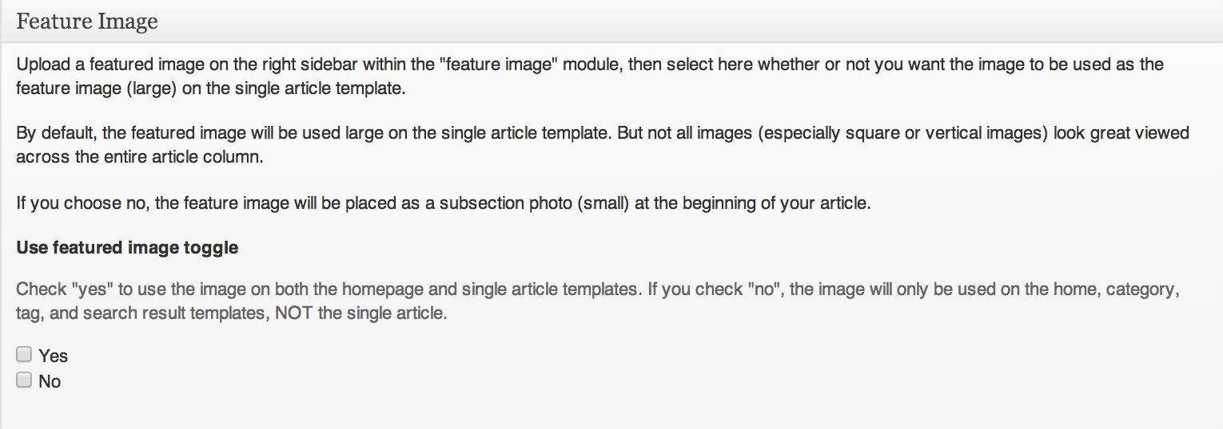

7. Upload Your Feature Video
Use this to put your YouTube video at the top of your article, for tv reporting courses. If you want to embed your video as multimedia in, for example, a radio class story, just paste the full public YouTube URL in the text box.

Load your story on YouTube. Place the YouTube ID in the first box.  NOTE: Copy only the text after the “=” symbol in the YouTube URL  Ex: In the URL “http://www.youtube.com/watch?v=aeAb0njzvpw,”  you would only paste “aeAb0njzvpw” into the box.  CAREFUL! If the link appears as something like this: www.youtube.com/watch?v=aeAb0njzvpw&feature=youtu.be  STILL ONLY INSERT “aeAb0njzvpw” into the box. | 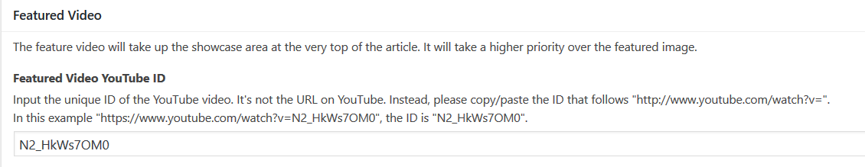
Feature Video Caption: Write a caption on your Feature Video in the box. Type a complete sentence of news describing what’s in the video. End the sentence with (c) 2018 your name.

Did you use someone else’s video? Then put the appropriate credit in the Video Credit portion. Be aware that you need permission for any copyrighted video, and most are copyrighted. Format: © 2018 Jane Doe.

IMPORTANT: now add your story script for accessibility:
Put your cursor in the top of the TEXT BOX, above your name and byline
Type: Video transcript:
With the cursor to the right of the : click on the ADD MEDIA button at the top>UPLOAD FILES, and DROP the pdf of your story script onto the upload window. (export from ENPS using FILE>PRINT>ADOBE PDF)
When it finishes uploading, click INSERT INTO POST.
The final text near the top should look like this:
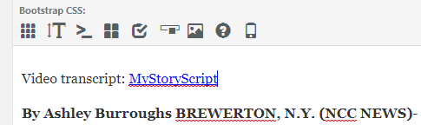
8. Add A Category  Categories are larger general topics. Stories fall under these columns lower on the website.  Find the “Categories” box to the right of your article content box. Select one and only one category. If there is not one that matches, leave CENTRAL NEW YORK. | 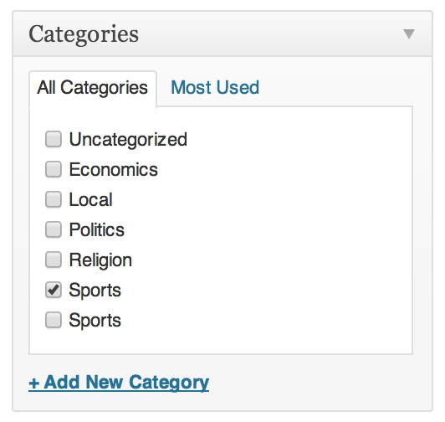
9. Add a Tag  Tags are topics within categories, for example: Armory Square, within the category, Business.  Find the find the “Tags” box located under the “Categories” box. | 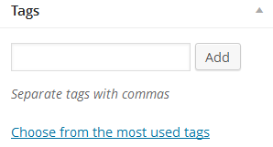
10. Click Your Course in the “Courses” box under the “Tag” box. This is extremely important – profs search for posts this way!

11. To Add extra audio, additional video &/or addition photos
Use the “Fields Table in the center section under the article to add audio, put a photo in the text or additional video.
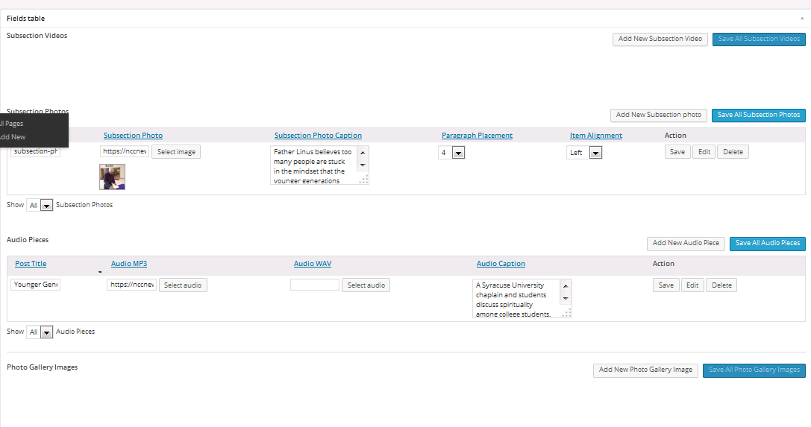 | Here’s where you add another video. Follow the same steps as adding Feature Video. Save.
 | Here is where you add additional photos. Click: “Add New Subsection Photo.” Follow the same steps as loading a Feature Image. Mark the paragraph where the photo appears (paragraph four or later). Align it left. Save all.
 | Add extra audio here (not your MAIN audio story, but extras like raw interviews, etc.) See instructions below.
 | Use this section only if you have a gallery of 4-10 pictures to add.
IMPORTANT: When you’re done, make sure you have hit “Save All Subsections…”

More on Audio
You must save your story as a draft before loading audio.
We now use SoundCloud for audio. You need a SoundCloud account. Go to https://soundcloud.com and log in with your username and password. Make sure you use the SoundCloud logo as your profile picture! If you need to retrieve that logo, get it from Google Images (not a copyright issue.)
Click “Upload” and follow the onscreen instructions to upload your mp3.
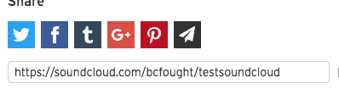
In SoundCloud, type a TITLE in the “Title” input field. This should be 3 to 4 words tops, more like a story slug! Choose for GENRE: News & Politics. Make sure your story is PUBLIC, and click SAVE. You should see a share link on the right; COPY the link in the share box, and return to your WordPress NCC News post.
To embed the track in your NCC News story:
- Back in Expressions, put your cursor at the top of your story, in the text box, above your byline/dateline. Paste the SoundCloud URL there. It will soon turn into an embedded audio player.
Underneath it, type your caption which describes the story. Make sure you have a subject and a verb. Make it a sentence describing the story, with a little promotion, so that a reader will want to click and listen. IT MUST BEGIN WITH SOMETHING LIKE: Click the play button above to learn why... Make it BOLD.
Example: Listen here to find which grocery store chain has the lowest orange juice price in the area. Hit “return” on the keyboard for a line space after the caption.
IMPORTANT: in this next line, you’ll add your story script for accessibility:
Type: Audio transcript:
With the cursor to the right of the : click on the ADD MEDIA button at the top>UPLOAD FILES, and DROP the pdf of your story script onto the upload window. (export from ENPS using FILE>PRINT>ADOBE PDF)
When it finishes uploading, click INSERT INTO POST.
The final text near the top should look like this:

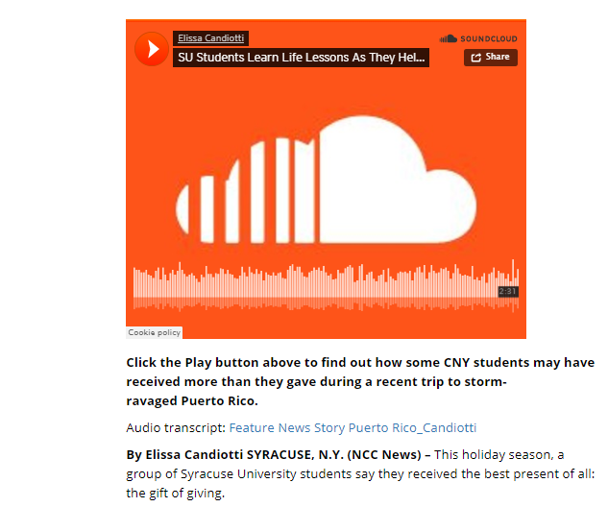

- In Expressions at the top right, click SAVE DRAFT. Then preview it to check that the SoundCloud audio appears at the top of the screen, and that your text lines adhere to the above format, a CLICK HERE line followed by the transcript.

12. Timeline

- Organize your material and write your copy
Find your dates, write your headlines, text and photo captions for each section of the timeline.

2. Upload your photos so each has a unique URL. You can put them on Instagram or NCCNewsOnline. Copy down the URL for each photo.
For NCC News Online, upload the photo as you would for the website. Note the URL at the far right
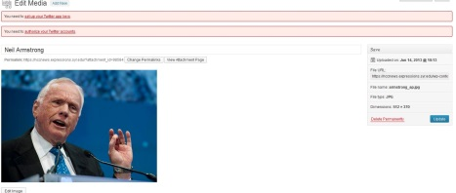

Alternate: If photo is on Instagram, try this: Click on the photo, right click the photo; choose “inspect element”; copy the highlighted line; paste into Timeline box.

The next steps are all on TimelineJS and you can follow those or see more explanation below.

3. Make and publish a Google spreadsheet from the TimelineJS template
  - Go to http://timeline.knightlab.com
  - Copy the Google template.
  - Replace the copy in the spreadsheet with your information from #1 and #2 above. Leave the same column headings, however, even if you don’t put something in that column.
  - Make it public. Click Share button (top right) . In the screen that appears look for “advanced” in lower right and click. Under “who has access” make sure you change it to “public”
  - Publish the spreadsheet by pulling down the FILE menu and clicking “publish to web”
  - Copy the URL

- Paste the Google URL into NCC News Online.
Put the URL from #3f into TimelineJS (where it says to put it) and it generates code (see below) for the timeline. This code with start with <iframe> Copy that code.

- Embed the code on NCC News
- Go to the post where you want the timeline.
- Paste the code from #4 into the section that is marked Timeline JS, as shown below
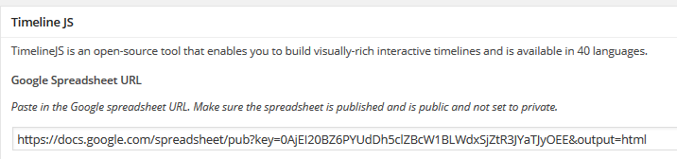
- Update the story

- Check how it looks at NCCNewsOnline. The timeline will appear at the bottom, after the story. Revise and republish, as needed.

12. Poll Note: you may NOT create a poll without your professor’s permission!!!

Creating a poll is a two-step process: creating the (free) poll on PollDaddy.com, then embed the poll on the NCC News web site.

- Create the poll on PollDaddy
- Create a free account on PollDaddy.com. This is linked to a WordPress account—you may be asked to create a WordPress account and link it to your PollDaddy account
- Select CREATE A NEW… and choose POLL
- The poll MUST be PUBLIC
- Remember to account for ALL choices; sometimes you need to add a final NOT SURE or UNDECIDED or OTHER to account for all possibilities
- Click CREATE POLL, and use the default PLAIN LIGHT style, and SAVE STYLE SETTINGS
- Finally, click ENABLE SSL FOR THIS POLL EMBED, then copy the inline Javascript embed code

- Embed the poll on NCC News Online

- From the NCC News web site Dashboard, click APPEARANCE>WIDGETS
- In the right side labeled POLL, click on the TEXT box. If it does not open/drop down, do this:
  - In upper right of browser, click on SCREEN OPTIONS
  - Click ENABLE ACCESSIBILITY MODE
  - In the URL window, you’ll now see this at the end of the URL: “widgets-access=on”
  - Type in the URL window, and change =on to =off, then hit ENTER to go to that URL
  - Now the dropdown Text box under POLL on the right side of the Widget page should open, allowing you to embed the poll code from PollDaddy. If the dropdown doesn’t work, repeat the above SCREEN OPTION steps, and it should work after a second try.
- When the text box opens, add the title NCC NEWS POLL
- Paste your PollDaddy embed code in the CONTENT box, click SAVE, and your POLL should be visible on the main NCC NEWS ONLINE page

