Chromakey Effect in Premiere:
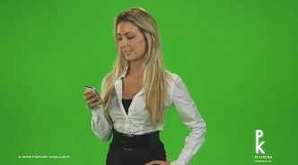
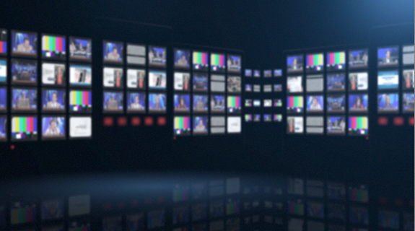
- Shoot a standup in front of a well-lit greenscreen (or even green cloth.) The exact color of the background doesn’t matter that much, but light green is good because most clothing isn’t that color. Shoot it so the greenscreen fills the entire background, and make sure the talent doesn’t wear ANY clothing the same color as the background. (If they do, it will “disappear” during the chromakey.)
- Find an image to be the background that the talent will be chromakeyed in front of. It could be a still image, or even video.
- Put background image/video on V1 (copy/paste it if necessary to last as long as the talent standup lasts in the timeline)

- Put greenscreen video on V2 [shot of talent in front of a greenscreen; lighting of entire greenscreen itself must be strong and consistent (no shadows) or else effect will not be clean.
- Go to EFFECTS>VIDEO EFFECTS>KEYING>ULTRA KEY and drag it to V2
- In EFFECTS CONTROL>VIDEO EFFECTS>ULTRA KEY>KEY COLOR, drag the “medicine dropper” to a spot on the greenscreen close to the talent, to choose that background color to key out
- Chromakey effect should now be visible. If not optimal, try changing EFFECTS CONTROL>VIDEO EFFECTS>ULTRA KEY>SETTING from DEFAULT to one of the other options.
- If greenscreen background is REALLY poorly lit, or is not totally green, you can try adding a masking effect in Premiere to help get rid of “garbage” in the background key:
- Select V2
- Go to EFFECTS>VIDEO EFFECTS>KEYING>EIGHT-POINT GARBAGE MATTE and drag it to V2
- Turn visibility of track V1 OFF, for the moment (turn off the EYE icon), so you just see the greenscreen shot in the upper-right hand window
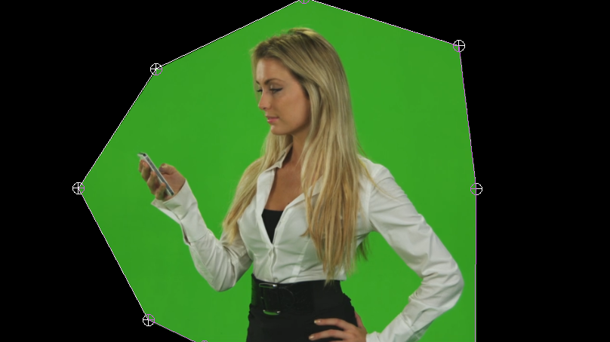
- In EFFECTS CONTROL>VIDEO EFFECTS> EIGHT-POINT GARBAGE MATTE, click on the square-shaped icon just to the left of “EIGHT-POINT GARBAGE MATTE” to make drag handles visible in the upper-right hand window (which should be showing your greenscreen shot; the SIXTEEN-POINT MATTE doubles the number of handles)
- Drag the handles away from the border, so they are as close to the talent as possible, but do not cut off any movement of the talent that takes place throughout the clip
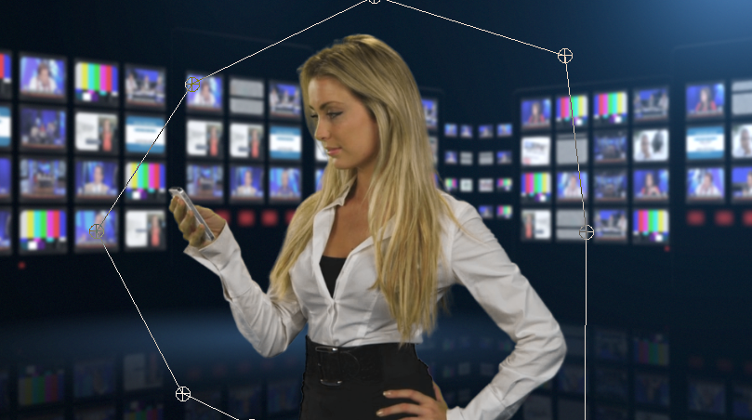
- Turn visibility of track V1 ON, (turn ON the EYE icon), and you should see a better chromakey when you playback the timeline; the handles won’t be visible during actual playback)

