 | Go to the SU Library homepage:  http://library.syr.edu | 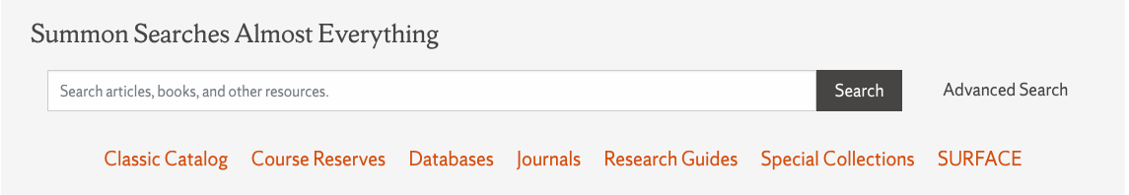
2. | Click on Databases  Although the top box says Summon Searches Almost Everything it’s better to go to the Databases
 | In the search box at the far rig, type in : Post Standard and click Go. | 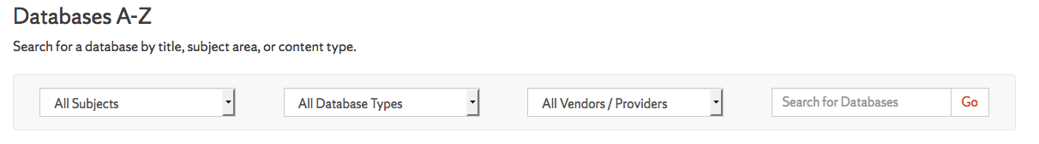
 | Click on Post Standard | 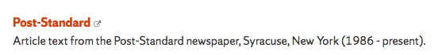
5. | Type key words in the search bar. Add more rows. You can specify: All text  - Lead/First Paragraph  - Headline  - Author/byline  - Date  - Or others  See search at right for the term Walsh in the lead/first paragraph and the term sidewalk in the lead/first paragraph.  Note below the search box you can search for the past five days or browse by date. | 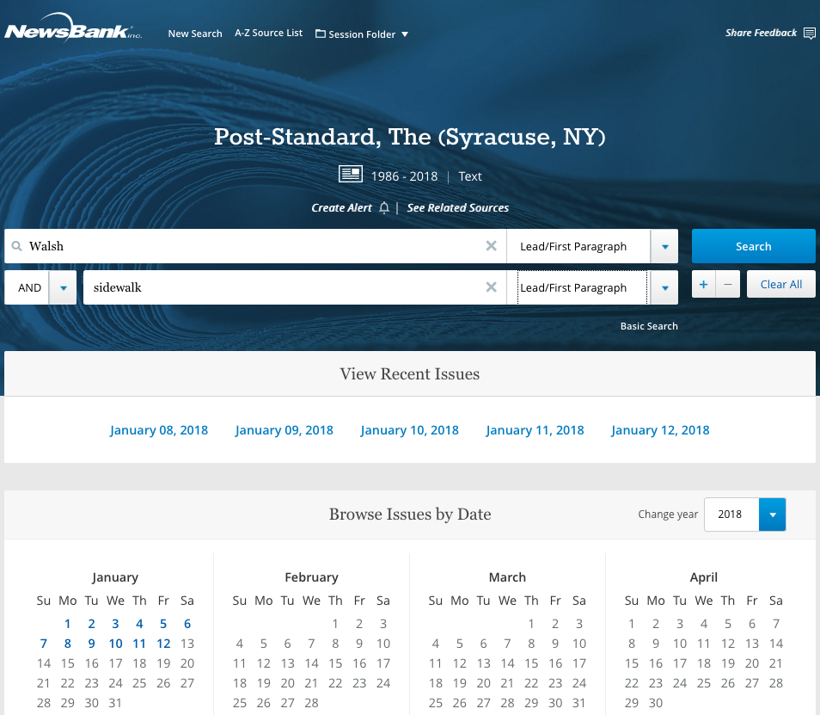
“XXX XXX” Put phrases in quotes, “gun control” is better than: gun and control
AND Finds documents containing all your search terms
OR Retrieves either word
NOT Retrieves stories with first word, but not your second word: Miner not Mary
ADJ[x] Retrieves stories with key words appearing within x words of each other and in the same order.
Jim ADJ3 Boeheim
NEAR[x] Retrieves stories with key words appearing within x words of each other,
but in any order. Halbritter NEAR25 “Turning Stone”
? Replaces a single letter within a word. Use a ? in place of a single letter.
Example: wom?n retrieves woman or women
* Replaces multiple letters within or at the end
Example: environment* retrieves environment, environmental, etc.
Example: R*house retrieves Redhouse

