

***updated 10/31/2019***

NOTE: only two people can connect live through Dejero at any one time; during the training not all of you will be able to connect at the same time, so we’ll have to rotate who is connecting, at which times.

1. Sign out a ZOOM mic from the cage to use with your iPhone. Make sure you have earphones/earbuds that work with your model iPhone, **especially if you a newer iPhone model without an earphone port/jack.** For older model iPhones, regular” earphones/earbuds are best, that are ONLY earphones (not the Apple model with a built-in mic) – but if that’s all you have, you can make do with it. You’ll need Bluetooth buds with the newer models, not an adapter cord, since the ZOOM mic will be using the lightning port.

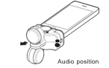

1. Make sure the ZOOM mic unit is plugged in BEFORE STARTING THE DeJERO APP. Plug the mic into the lightning/power jack of the iPhone; it should orient like the diagram indicates. Set the record dial to about 6. Make sure your iPhone CASE is not preventing the mic from plugging in fully.
2. NOTE: YOU MUST USE AN EAR/HEADPHONE FOR DEJERO; IT DOES NOT ALLOW YOU TO LISTEN THROUGH THE IPHONE SPEAKERS, YOU MUST USE EARPHONES!
3. On an older model iPhone with an earphone jack, plug your earpiece into the empty IFB jack on the ZOOM mic. Make sure it is pushed in all the way. Talent should put on IFB/earpiece.

**If there are any problems using the ZOOM mic with Dejero, pull out the mic, pack it away, and plug ONLY the IFB/earphones into that cable. You will use either the iPhone’s built-in mic, or Apple’s built-in mic in the earphone cord, instead of the ZOOM mic – but they are prone to picking up lots of background noise, so make sure you are located in as quiet an area as possible, and make sure the talent is as close to the iPhone mic as possible.**

1. Make sure iPhone volume is turned up by adjusting VOLUME control on the phone.
2. **At this point, you must make sure you are connected to AIR ORANGE X!**
3. On the iPhone desktop, press SETTINGS, then scroll down and tap on the Live+ Mobile app
4. Make sure on the right:
   1. **the MIC and CAMERA are turned on**
   2. **VIDEO=NTSC/720p**
   3. **LIVE STREAMING IFB Output=ON**
   4. **LIVE STREAMING Preset Latency=ON**
   5. **CELLULAR NETWORK=Use Cellular Radio=ON**
5. Assuming you have already downloaded the app, tap the Dejero icon. Enter the temporary username/password given you, if you haven’t already.

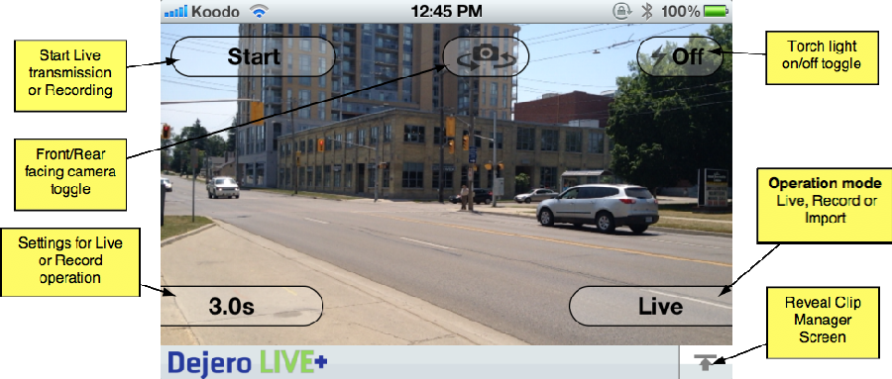

**All of the functionality of the application can be accessed from the buttons on the screen. The main ones are the top three buttons, which start/stop and control the camera on the device. The lower-right button should say LIVE – toggle it if necessary to LIVE.**

1. From the main Dejero screen, choose the camera you want to use from the CAMERA SWITCH icon at the center-top of the screen. Use the camera pointing AWAY from you, unless you are shooting as a one-man band; then, the camera FACING you would help you frame yourself, despite lower resolution.
2. Tap the START button in the upper-left of the screen to transmit a live picture back to the studio. you should see a meter for wifi (both cell and wifi if you are using the BDJ iPhones)

screenshot

1. While broadcasting live, the ‘Start’ button will change to ‘On Air’ and the color will change to green. The left-middle part of the video display shows a VU meter for the microphone input.
2. Along the bottom of the screen the app will display some statistics showing the transmission strength. The first number on the left is the video encoder rate in bits per second, the higher the number, the better the quality.

**0-200 kb/s – very poor quality or possible no video signal**

**200-750 kb/s – low quality, but suitable for ‘head shots’ with little motion**

**750 – 1500 kb/s – medium quality, suitable for motion**

**1500 – 2200 kb/s – high quality video**

**2000 kb/s+ – excellent quality video**

1. Tapping the screen can **focus** the rear-facing camera. The front facing camera is a fixed focus camera and is always in focus. As well, when the camera is switch from the front facing camera to the rear-facing camera the camera is automatically focused. BUT – IF YOU NEED TO LOCK THE FOCUS (and/or exposure) DOWN, JUST PRESS AND HOLD THE FOCUS SQUARE IN THE VIEWFINDER UNTIL THE YELLOW AE/AF LOCK APPEARS.
2. There is a zoom slider along the right hand side.
3. Through the earpiece, you should be able to hear any studio audio, and your producer. There is a delay of about 1-2 seconds.

1. When finished, press the green ‘On Air’ button (previously labeled ‘Start’) to stop transmitting live and go off the air (OK to GO OFF AIR.) The app will stop transmitting and notify the Server that it is going off the air. This phase will take about 2 seconds and the button will be labeled ‘Stopping…’ during this phase. When the stopping phase is completed the app will reset back to the main camcorder screen.
2. Press the iPhone HOME button once to minimize Dejero.
3. 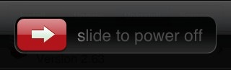Power is limited; power off if not being used for long stretches by pressing and holding the POWER button until the SLIDE TO POWER OFF option appears…slide the arrow to the right to power the iPhone OFF.

screenshot**Errors While Broadcasting**

If there are any errors while broadcasting live a yellow status band will appear on the bottom of the screen indicating the type of error that occurred.

When the error clears the yellow band will disappear. Some of the error messages that can occur during live broadcast are:

**Not enough bandwidth to transmit** No video or audio is being broadcast because the connectivity

connections are too poor. Find a different location with better cell coverage.

**No Internet connectivity** The app has lost all Internet connectivity. Relocating to a different

location and restarting the broadcast is a resolution.

**Latency of signal too high** There is enough bandwidth available, however the latency or delay of

the broadcast is too high to transmit in the current delay setting. This error will occur if the

app is set to a low delay (1.5 seconds or 3.0 seconds) and the network conditions are too poor to transmit video at that setting. Restart the transmission.

**Special Dejero Situations**

**Sending Recorded iPhone Video Back to the Studio**

Besides transmitting live video, the Dejero LIVE+ Mobile App features the ability to record video and send this recorded video to the server at a later time. Using this technique, a high quality video can be recorded when network conditions are too poor to transmit live and then uploaded later. A video can also be imported from the device’s camera roll and uploaded to the Dejero LIVE+ Broadcast Server. The video could be recorded or edited with another app using this technique.

To change modes from **Live** transmission to **Record** or **Import** press the mode button in the bottom right corner of the screen.

**Recording a video**

When the app is in **RECORD** mode, the lower left settings button allow you to set the encoding rate of the recording video – 2.0Mbps (low), 4.0Mbps (medium), 6.0Mbps (high). The higher the encoding rate, the better quality recording and the longer it will take to upload the file to the Dejero LIVE+ Broadcast Server. Try MEDIUM: 4 Mb/s. Press the Start button to begin recording video. While the app is recording you can use the camera control buttons to switch the front and rear cameras, and turn the torch light on/off.

While the app is recording video the ‘Start’ button label will change to ‘Recording’ and the color of the button will turn green. In the bottom right corner, a timer will start indicating the recording duration. Press the ‘Start/Recording’ button again to stop recording.

**Review, Rename, Send, Save or Delete**

Immediately after recording the video the app enters a phase where you can review the video.

Tap on the filename of the clip to give it a better filename: **add your last name**, and **whether it’s a VO or SOT to the START of the filename** for this exercise. (I don’t think you can delete the generic remaining filename.)

Double-click the clip thumbnail to go fullscreen, and use the playback controls that allow you to pause, rewind, scrub the video. The audio will play out the device’s speaker (or earphone, if the ZOOM is plugged in.)

Tap CONFIRM & EDIT. You can send the video to the Dejero LIVE+ Broadcast Server by tapping the TRANSFER option in the upper right.

**Sending video**

Pressing the send button on the screen, will start the send operation. A thumbnail of the video is generated, as well as other metadata. The clip manager screen will slide up and the sending of the clip will start.

**NOTE: at first, it will say QUEUED as it prepares to send—don’t panic, that’s normal, it should actually start sending soon.**

Sending will continue in the background, you can record another video or even go live (the send will be temporarily paused during live transmission). Press the UP/DOWN arrow to enter or exit the clip manager.

**Clip Manager**

The clip manager screen allows you to monitor the sending of clips, pause the sending of clips and deleting of clips being sent.

On the left side of the screen are some status items – the server the files are being sent to, the upload speed in kilobits per second and the estimated time and total bytes remaining for clips being uploaded.

On the right side of the screen is a list of clips being sent. A thumbnail representation of the video identifies the video, a progress bar shows how much of the video clip has been sent and each clip has a status button that indicates the status of the clip being transferred. There are four possible status states:

**Sending**. The clip is currently being sent. Only one clip at a time will be in the sending state.

**Queued.** The clip is queued to be sent after the clips above have been sent.

**Complete.** The clip transfer has been completed and is available on the Server for playback. Only complete clips can be played, partially transferred clips are not playable on the Server.

**Paused.** Clip transfer has been paused by the user. At any time the clip is in the Sending or Queued state, you can press the status button to pause the clip. Pausing a clip transfer is a means to prioritize a particular clip for transfer, by pausing the clips that are ahead (above in the list) in the Queue. Pressing the status button while a clip is paused will start the transfer for that clip again. The screen shot above shows the top clip ‘Paused’. The clip below immediately goes from Queued to Sending, thus transferring the second clip before the first.

**Deleting clips**

To delete the clip from the clip manager swipe your finger over the clip from right to left. A TRASHCAN/Remove icon appears on the right. Tap the Delete button to delete the clip from the clip manager. Or tap anywhere else to cancel the delete operation.

**Dismissing the Clip Manager**

Press the down arrow button in the top right corner of the screen to close the clip manager. The app will return the main screen where you can record another clip or go live on air. This can be done while clips are being sent to the Server.