Studio C Crew Positions
Teleprompter/Timer/Newscast Finalizer
Description:
You will need to know name of the show you are about to broadcast. Generally a show is designated as the 4pm show or the 4:45pm show.

You must understand how to load, enter, exit, and operate the teleprompter system. During the show, pay close attention to the stories and the pace of the various anchors.

You will also set a countdown clock to time the 2:00 commercial breaks.

At the end of each show, your job also includes the responsibility of transferring the recorded newscasts to the class folder where students can view the newscast.

To activate the rundown in the teleprompter:
- Make sure the teleprompter PC is logged into the PROMPTER account (on the label at top of PC monitor)
- double-click the WinPlus icon on the computer desktop, or click on it in the Taskbar if it’s already open
- the newscasts should hopefully be listed as available already in the MOS Program/Event Display window
- open the show by double-clicking on the BLUE part of the rundown
- Advance the show using the remote controller
- Note the Next/Prev story buttons, and the “Run order top button (which instantly takes you back to the top of the show)

To start the prompter at a certain story (not the beginning):
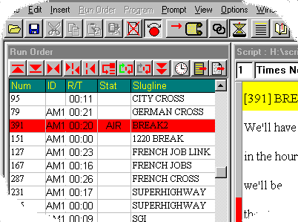
- click in the WinPlus Run Order window, on the slug of the show where you want the prompter to start
- press the F9 key

Time each of the commercial breaks. When you first arrive, set the CLIP TIMER clock PRESET to 02:00. Then, during the newscasts, when the director fades to black for commercials, press the START button to count down to zero. Loudly inform the room when there is 1 minute left in the break, :30 left, then :15, and :10. After the break is over, quickly press STOP, then PRESET to prep for the next break
Uploading recorded newscasts to the class files folder:
As soon as a newscast concludes, transfer the recorded file as follows:
- Press the PRINT SCREEN key to open the KVM/Video router software
- Scroll to UTILITY PC 1 and select it
- After the new PC desktop appears, open the ftp program FILEZILLA
- The server is represented by the file explorer pane on the right labeled REMOTE SITE; your own computer is seen in the left pane labeled LOCAL SITE
- NOTE: BE CAREFUL! YOU CAN DELETE MATERIAL, EVEN FILES NOT YOUR OWN, SO PRACTICE SAFE FTP’ING. The ONLY thing you should EVER do is drag and drop files into the server, NEVER rename, delete, etc.!!
- In the top left panel, navigate to the G:\drive>BDJ Newscasts folder
- In the top right panel, click on the MP4 folder
- In the bottom right panel find the day’s 4pm and 445pm newscasts
- Drag the newscasts, one at a time, to the bottom left panel to transfer from the server to the BDJ Newscasts folder; you will see the transfer progress in green on the bottom

When using the teleprompter, some things to keep in mind:

Do a practice the show when you arrive – at 3pm -- to make sure the prompter is working.

If a producer should add a story into the rundown after you’ve already cycled past it, the only way to access the new script is to reload the script into the prompter. Do this by clicking, in the WinPlus Run Order window, the slug of the show where you want the prompter to start, and pressing the F9 key.

