NCCNewsOnline – How To Post – *New Website*
7/12/2020

- First, if you are trying to create a web post from off-campus, make sure you connect to SURA, the SU VPN:
SU Remote  Access Tool  [SURA, VPN] | Click the link to download the SU VPN called SURA. It will allow you to access:  - NCCNEWSONLINE (to create a post)  - Your SU G drive (CLASS FILES)  - Your SU H drive (your personal SU Desktop, storage, etc.) • Your SU Email
- Go to nccnews.info (https://nccnews.newhouse.syr.edu/wp-admin/ ) and log in
- On the left-hand side under Posts – click Add New
- Enter headline where it says “Enter title here” o Headline must have a subject and a verb, and should be short (no more than two lines when viewed in the actual post)
  - Capitalize each word
- Summary text: this is the two- to three-sentence summary of your story that is shown on the home page and gets sent out over social media, 250 character max
- Subheading: This can be a little longer than the headline and will appear on the story page. This should be a sentence with subject, verb and period at the end. Capitalize first word and proper names.
- Mobile title: this is a shorter version of the headline that will appear on mobile devices o By default, it’s the same as the regular headline, but you can shorten it, 75 character max
- Choose your course from the right-hand column (this is how your professor finds your story)
- Choose a category from the right-hand column – you cannot create new categories
- Enter several tags from the right-hand column – you can create new tags
- Adding Images o Photos must be 2MB or smaller
  - Photos MUST be 1920 x 1080 pixels; if smaller will look bad when enlarged on the site o Always upload images shot landscape, not portrait o See later section for tips on resizing images
- Header Image – this image appears with featured stories on the home page and on the story page o The header image is larger so it can be a wider view of the subject: MUST BE HORIZONTAL, 1920x1080 pixels
- Preview Image: this is the image that appears with stories in categories on the website home page o The preview image is smaller so it should be a narrower view of the subject
- Set Header/Preview Image o Add Image o Select Files o Select image to upload o Caption: a sentence of news, complementing what the photo shows. o Alt Text: a sentence specifically describing what is in the photo.
▪ “A white dog with a red ball and a black dog with a green ball.”
  - Photography Credit: your name, when you took the photo. If you have written permission to use a photo from another copyright owner, then put his or her name in. Remember that you need permission from the person who took the photo, not just anyone who has a copy of the photo. If you are using a photo from Creative Commons, use the instructions on this page for how to attribute it. It needs to be clear to your professor where the image came from, and that it is legal, or your post will not be published.
  - Photo Year: the year the photo was taken--mandatory o Crop the photo by dragging/moving the box
▪ The box maintains aspect ratio

How to post text and photos in the body of the story
- Story Content – click Add Content o Written Content
  - Admin Title: identifies what kind of content this is – write Text
  - Editor: write the story here
- Dateline in bold:
o FULTON, N.Y. (NCC News) — o start article right away, no return
- Tool bar toggle expands options
- To add a photo in the story, place the cursor where you want the image to go, then click Add Media
▪ Upload or choose photo, include caption, alt text, credit and year for each photo
• Click on photo to choose alignment: left, center, right, none

How to post video
- Story Content – click Add Content o Embedded Content
  - Admin Title: identifies what kind of content this is – write YouTube link
  - Embed Choice: Audio/Video
  - Embed Display: Set as Featured Content – Yes
  - Embed: copy complete URL from YouTube
- Video will appear below
- Media Type: Video
- Transcript: copy and paste your script o Remove Macros, such as Take PKG o Add in who’s talking: Reporter, Mayor Walsh, etc. Should have this format:
    - ANCHOR: alskdf kajf;dl ksdf
    - REPORTER: asdlfj dfjasd jsdkfj sd
    - JANE DOE: “ asdlkfj sdkfj sdj alks ▪ More Options: skip

How to post a photo gallery
• Story Content – click Add Content o Photo Gallery
- Add to gallery
- Upload/click on all the photos you want to include in the gallery
- Include caption, alt text, credit and year for each photo ▪ Select
- Rearrange the order of the photos by clicking and dragging

How to post audio
Your audio file should be featured at the top of the story; include a Header/Preview images, followed by the primary audio (wrap?)
- Go to SoundCloud and click on your story
- Copy the URL
- Add Content
- Embedded Content o Admin Title: identifies what kind of content this is – write SoundCloud link o Embed Choice: Audio/Video o Embed Display
  - Set as Featured Content – No
  - Content Alignment: Center (Breaks inside content area) o Embed: copy complete URL from SoundCloud
  - Audio will appear below
  - Media Type: Audio
  - Transcript: copy and paste your script
- Remove Macros, such as Take PKG
- Add in who’s talking: such as Reporter: or Mayor Walsh: , etc.
- More Options: skip
- If adding additional audio, please add additional Embedded Content, and include a transcript on everything. If you embed audio within the text box, you MUST also upload and embed a transcript file adjacent to the SoundCloud URL.

How to submit your story
- Continue to add content blocks until you’re finished
- Close all content toggle triangles (on the right-hand side) and then drag the content blocks to the order you want them
- Save Draft
- Preview to make sure it’s the way you want it
- Click Submit for Review when you’re finished
o Once you click Submit for Review, you can no longer make changes to your story o Do not click Submit for Review until you’re absolutely sure you’ve finished editing
- Professor or supervisor will publish it when it’s OK, or professor will adjust it so you can publish it.

Use the tool bar above the text box to format text
Format Bar: The default is paragraph. Skip it.
Bold: Create bolded font.
Italics: Create italicized font.
Unordered List: Create a list in your article with bullets.
Ordered List: Create a list with number.
Blockquote: Highlight/indent a quote.
Align text: Left, Center, Right
Link: Add a hyperlink to words in your article.
Unlink: Take a link away from words in your article.
Insert Read More Tag: Do not use.
Full Screen: Expands text
Toolbar Toggle: more options

Strikethrough: Create font with a line through it.
Horizontal line: insert line all the way across the column (don’t use)
Text color: don’t use
Paste as Plain Text: Use when you paste from the web or another document so text is formatted correctly.
Clear formatting: Removes all formatting from highlighted text.
Insert Custom Character: Gives a choice of many custom characters.
Outdent: Moves indented text back to the left.
Indent: Indents text to the right.
Undo
Redo
WordPress Help

What to do if your captions do NOT save along with the photo:
In order to avoid that problem, students need to complete anything they need to do with the photo in one sitting when they upload the photo. If they upload the photo, save it, then return later to add captions, their captions will probably disappear. So this is the recommendation:

A. Normal Process (best practice)
- Upload the Photo
- Add the meta data – alt text, caption, photo credit
- Choose Select

To alter the photo in any way, follow these steps:

To add or edit the meta data
- Delete the attached image by selecting the X (do not edit select the pencil )
- Find the original image (the original image will not have “acf_cropped” in the name)
- Add/edit the meta data – alt text, caption, photo credit
- Choose Select

Below is an example of how the original and copies appear in the media library
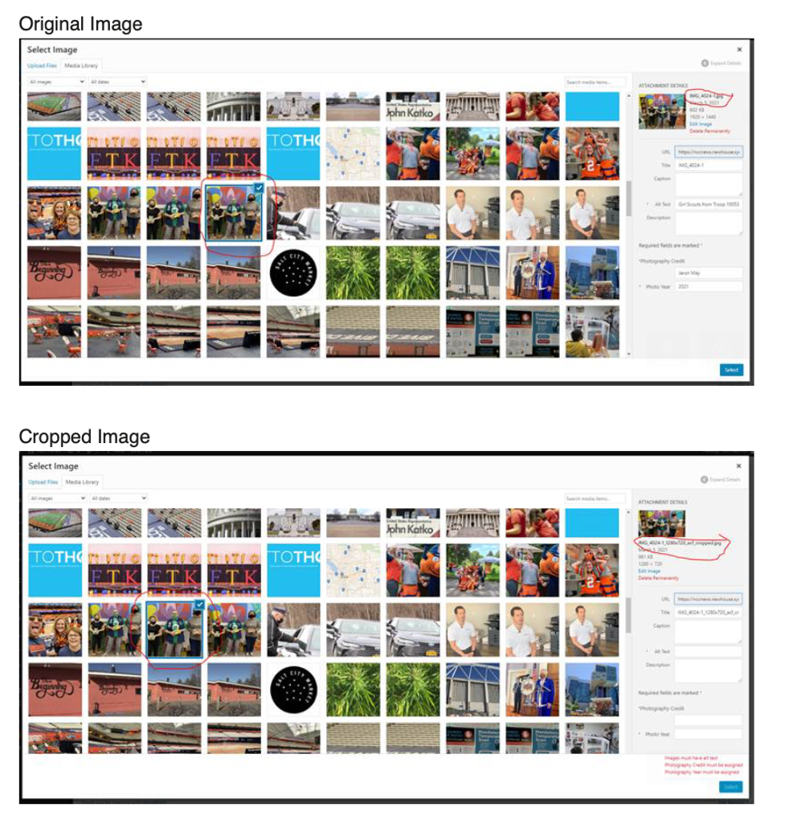

Checklist: Avoid the 10 Most Common Mistakes

- Spelling is correct. o Review what’s underlined in red

- Headlines have a subject and a verb. o Each word in the title headline is capitalized

- Make sure the transcript of the video or audio appears before the story lead, and if automatically generated by YouTube, has been “cleaned up” appropriately – double-check proper nouns.

- Verbs are past tense for quotes.

- Quotes are punctuated correctly, with attribution after the first sentence. o Examples:
  - “It’s great that the state has done this,” Strobel-Gower said. “People with disabilities don’t use the word handicapped, and haven’t for a long time.”
  - “I feel sorry for the taxpayers, but this is a much bigger problem than just the Town of DeWitt,” said Jim Clune, one of the protestors. (Put “said” first if a phrase comes after the name.)

- Photos are horizontal (landscape), not vertical (portrait).

- Photo captions are a sentence of news with a subject and a verb. They add news or information to what the picture itself communicates.

- Make sure the photo copyright notice appears in this format: (c) 2020 Newie Newhouse

- The story is tagged by topic and by class.

- You’ve looked at the published story online. Video and audio play correctly.

Resizing a Photo
- Try http://resizeimage.net/ (save Photos as 1920 x 1080 pixels)

- Try using Adobe Photoshop in BDJ labs

In Photoshop open File>Export>Save for Web (Legacy)

This will bring up dialog and preview to set the new image properties (see below).

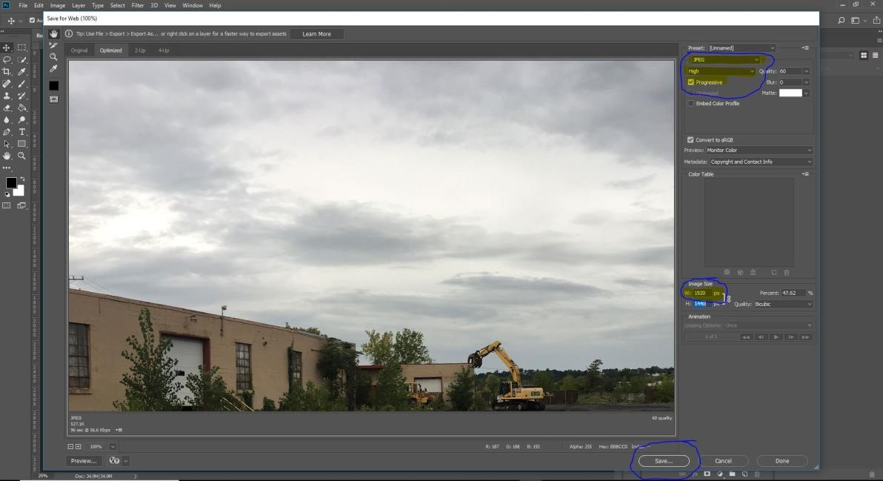
Image should be saved as jpeg or jpg with a maximum width of 1920px.

If the image is still too large the image quality should be lowered.

To optimize the image for web it is better if it is set as Progressive

