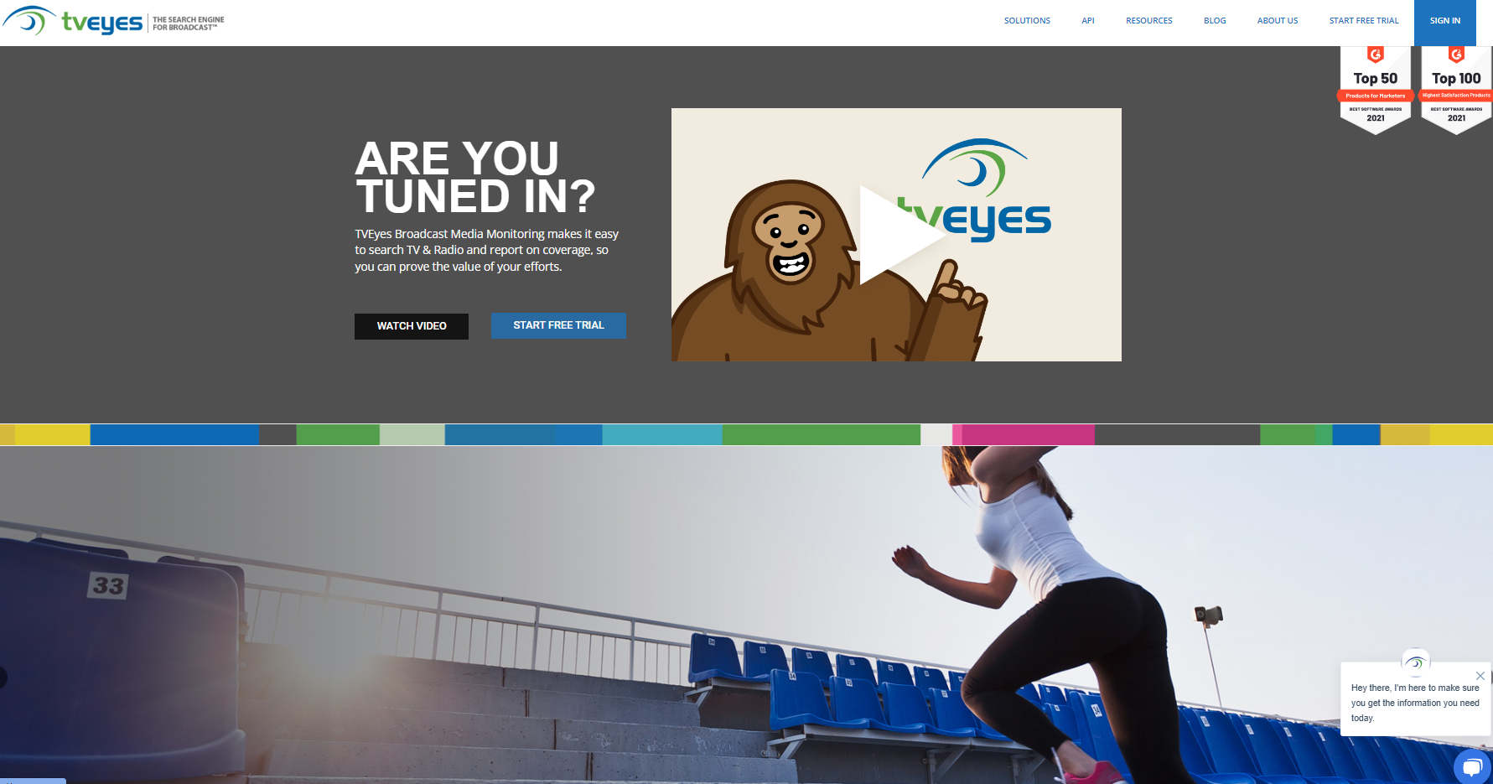 |  | Go to www.tveyes.com  Sign in (see blue square upper left):  Login: nccnews@syr.edu  Password: natpop  Only 2 people can log in at the same time.
 |  | Click Date/Time search in Blue Bar
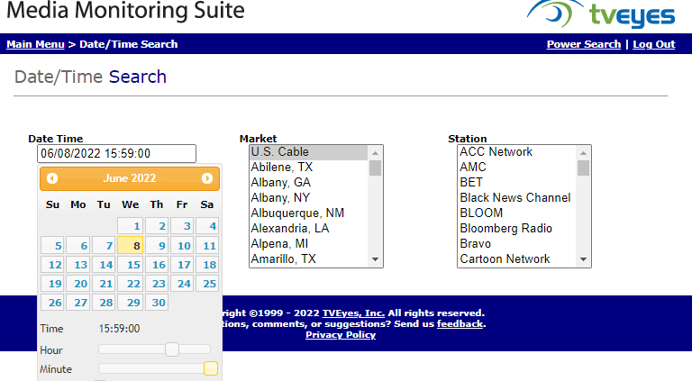 |  | Select the date in the calendar (click under Date Time) to get it  Select the time with the slider bars Pick the market & station (be sure to distinguish between radio and TV)
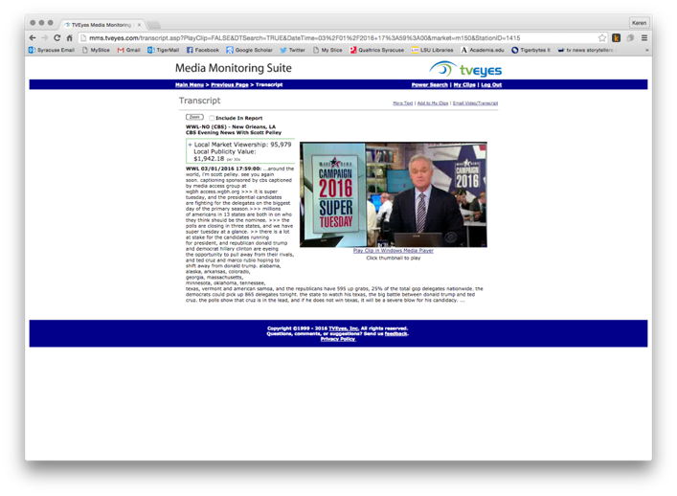 |  | TV: Click the window, not the link to play the clip  Radio: Click the play button
RADIO | TV
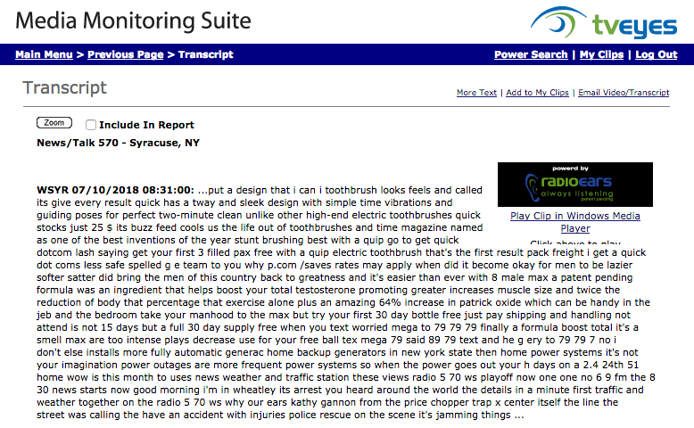 | 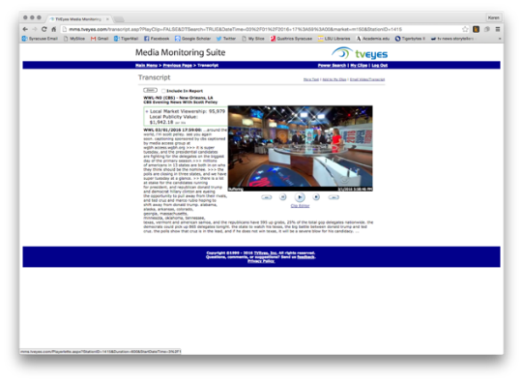 |  | Next a Clip Editor should show up
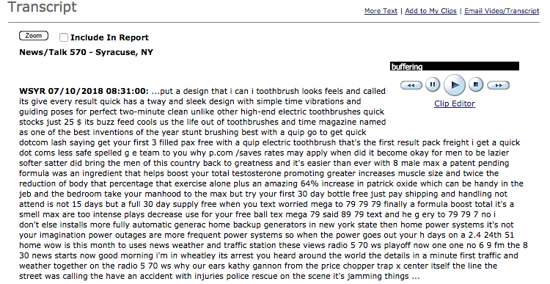 | 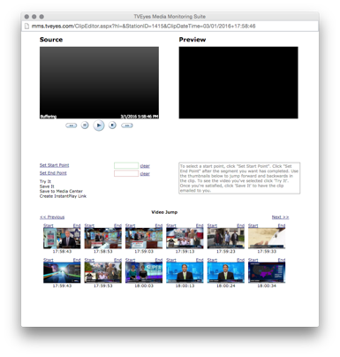 |  | Play to find the portion you want to record  (clips must be less than 10 minutes)
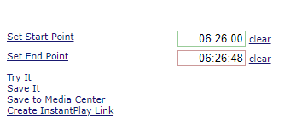 |  |  | Type in/out time.  Click “Save to Media Center”. Select format (high def is too big a file)  Click Continue
TO FIND YOUR EMAILED CLIP:
Look in Microsoft TEAMS in the Group-NCC News channel (or in your class TEAMS account if you have one)

Click the clip editor link)and you should see the following for radio or TV:

RADIO | TV

Type in an in and out time on your clip (clips can only be up to ten minutes long )

RADIO | TV
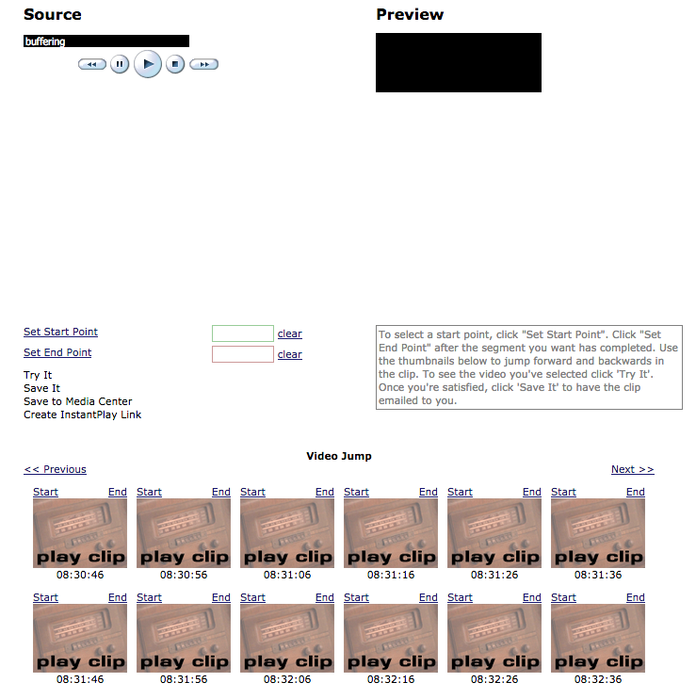 | 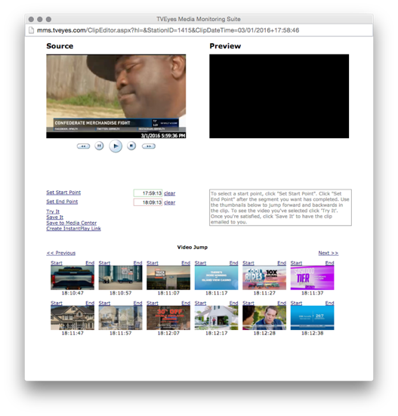

Choose “save it” and select the format for radio or quality of the video clip (don’t choose High Definition as it makes for a bigger file to download).

