ADOBE PREMIERE PRO
AUDIO EDITING QUICK REFERENCE GUIDE
Prof. J Elliott Lewis / Updated January 2023

The XF705 camera will record audio on four channels.
External mic (Lav or Stick) = Channels 1 & 2.
Built-in camera mic = Channels 3 & 4.
For basic editing, we only need two audio channels.

AFTER IMPORTING YOUR VIDEO INTO ADOBE PREMIERE BUT BEFORE PUTTING ANYTHING ON THE TIMELINE, REVIEW AUDIO SETTINGS. Under the Project tab in your media source browser, highlight the bin contents (turns light grey). Then go to Clip Modify Audio Channels.
Make sure “Clip Channel Format” is set to “Mono.”

When selecting a clip from an interview or a standup to place on your timeline, you must select the proper audio channel! Failing to isolate the proper channel will give you bad audio!
Source Destination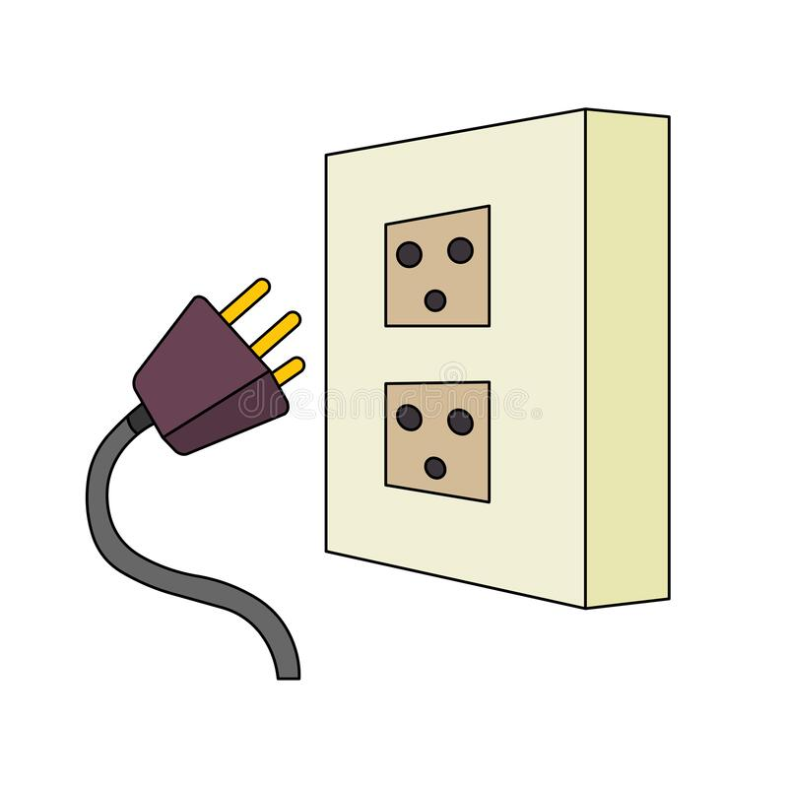

The two boxes on the left (A1, A3) represent your source audio channel. The two boxes on the right (A1, A2) indicate the channel on the timeline where the audio will end up.

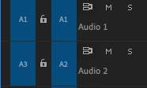

Note the “M” and “S” in the diagram. When listening to a clip, the “M” button will Mute an audio channel. The “S” button will Solo that audio channel and mute all others.

AUDIO LEVELS: Your primary audio, typically reporter narration and soundbites, should range between –20 to –14, peaking at –12. Natural Sound underneath narration = –36 to –30.

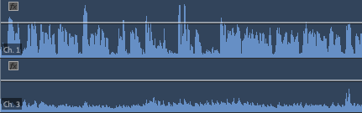
Primary Audio: Reporter Narration and Soundbites

Secondary Audio: Natural Sound

ADJUSTING AUDIO:
Adjust sections of audio using “Key Frames” (a point of change) represented by the dots.
Add key frames in pairs to create an on-ramp and an off-ramp for raising and lowering levels.

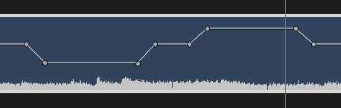
To add a keyframe on Mac: Command+click
To add a keyframe on PC: Control+click

IF YOU MAKE A MISTAKE: (Mac) Command+Z = UNDO (PC) Control+Z = UNDO

