NEWSCAST PRODUCER
IFB (Interruptable FeedBack) CONTROL ROOM HANDOUT

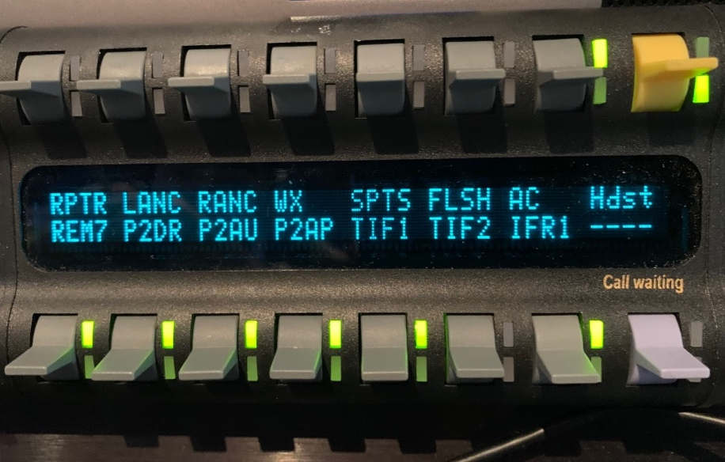
Press down and hold to talk for top row channels.

Press down and hold to talk for bottom row channels.

Top Row: RPTR = Reporter when in studio
LANC = Left Anchor
RANC = Right Anchor
WX = Weather when in studio at Green Screen
SPTS = Sports
FLASH = FlashCam in Newsroom
AC = All Call: Talk to everyone on IFB

Bottom Row: TIF1 = Talk to LiveU 1 Operator
TIF2 = Talk to LiveU 2 Operator
IFR1 = Talk to All Remote On-Air Talent
(Including Weather when outside)
Note: Sometimes IFR1 changes to read “ICom.”

On-Air Talent should be in place at least 10 minutes before air time to allow for mic checks, IFB checks, set audio levels, and troubleshoot any issues that arise.

* LiveU operators need to call in on the “Tiff” line to establish communication with the control room. (Tiff #1 = 315-443-8518 / Tiff #2 = 315-443-5096)
* On-Air Talent on LiveU may experience a slight delay.
* Producers should try to cue On-Air Talent via IFR1 about 1-2 seconds before they should start talking. As a backup, producers can cue the LIveU operator via Tiff 1 or Tiff 2 and have the LiveU operator cue talent.

